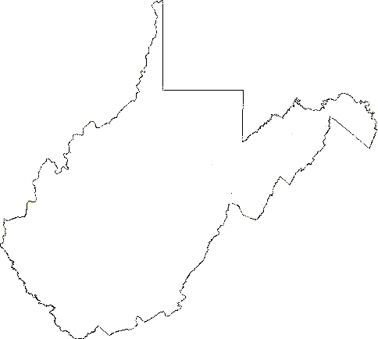
__

West Virginia Writers, Inc.
West Virginia Writers, Inc.
906 18th Street

Vienna, WV 26105

WHO WE ARE

West Virginia Writers was established in 1977 by invitation of the West Virginia Arts and Humanities Council. We are the state's largest organization for writers.

With the support of members and sponsors, our nonprofit, all-volunteer organization fosters, assists, and coordinates statewide activities in support of writers and writing programs.

We are founded on the fundamental principle that the written word is one of the distinguishing characteristics of all human endeavors. Our aim is to expand and develop creative writing and professional opportunities for writers and to connect the state's writers with others in the literary community and the public at large.

The Executive Board: six officers, the president emeritus, and 10 regional representatives plan and conduct our year-round programs.

President, Cat Pleska, Scott Depot
1st Vice President, Teresa Newsome, Madison
2nd Vice President, Susanna Holstein, Sandyville
Secretary, Craig Snider, Clarksburg
Treasurer, Christina Freeburn, Keyser
Parliamentarian, Belinda Anderson, Lewisburg
President Emeritus, Terry McNemar, Stonewood
Web master, Podcast guru, Eric Fritzius,
Princeton

OUR MISSION AND GOALS
- Support and encourage serious writing activities within the writing community
- Establish a networking system for writers
- Promote writing as an art form
- Give voice to our people and way of life
- Educate the importance of writing
- Encourage appreciation of the literary arts
- Expand the horizons and deepen the appreciation of life, culture, and communication among writers and all citizens of West Virginia


2011-2012

Brochure

West Virginia Writers, Inc.
HC 72 Box 232
Keyser, WV 26726
e-mail: westvirginiawriters@gmail.com
www.WVWriters.org
WEST VIRGINIA WRITERS
ANNUAL WRITING
COMPETITION
- Established in 1982
- State’s largest writing competition
- Open to West Virginia residents or members of WVW
- Adult, Student and Youth Categories
- Manuscripts accepted from January 1 through March 30
- Over $124,500 in prize money awarded since 1982
WHAT WE DO

- Enhance our culture, our literature, the lives of our readers and writers, and West Virginia's future
- Provide frequently updated listings of events, writing contests, writing markets, writing classes and workshops of interest to writers in our region via our blog, at blog.wvwriters.org.
- Host a regular podcast featuring interviews with writers throughout Appalachia, podcast.wvwriters.org.
- Help beginning writers find their way
- Encourage writers to persevere until they publish their work
- Serve writers at every stage of their development, in all genres
- Conduct an annual writers’ conference
- Sponsor an annual writing competition
- Furnish an online newsletter
- Provide a quarterly mailed newsletter
- Coordinate regional workshops and readings.
- Provide networking among writers
- Bind a scattered multitude of writers into a cohesive group
- Conduct literary community outreach activities
- Hold regional workshops and readings
- Publish anthology of WVW award-winning works (available at Tamarack, local bookstores, and West Virginia Writers)

WEST VIRGINIA WRITERS ANNUAL WRITERS CONFERENCE

- Established in 1978
- Held the 2nd weekend in June at Cedar Lakes Conference Center. Ripley, W.V.
- Reception
- Three days of workshops
- Entertainment
- Peoples’ Choice Prose and Poetry Reading Competitions
- Writers’ Wall writing display and competition
- Awards Banquet
- Writing Competition Awards Ceremony
- Social activities
- Bookstore
- Annual Business Meeting
- Silent Auction

MEMBER BENEFITS

- Access to West Virginia Writers' Website and blog at www.WVWriters.org
- Quarterly newsletter with news about writing opportunities in the state, writing tips, and much more
- E-mail newsletter with information on publishing, markets, and contests
- Fellowship with other writers
- Information on how to contact other writers and speakers and how to organize local writing and reading projects
- Registration discount at annual conference
- Online Critique Group for writers
- Online Roundtable - an online discussion group for writers.
- Support of local and regional writing groups
- Promotion for your published work through WV Writers press releases and newsletter page
WEST VIRGINIA WRITERS, INC.
MEMBERSHIP APPLICATION
Please Print or Type Information

NAME ______________________________

ADDRESS___________________________

CITY________________________________

STATE_______________ZIP_____________

COUNTY_____________________________

PHONE______________________________

E-MAIL ______________________________

REFERRED BY _______________________

- Adult memberships $20/year
- College student (under age 25) memberships $10/year
- Youth membership (under age 18) $5/year (Due annually on July 1)

MAIL CHECK AND APPLICATION TO:

WEST VIRGINIA WRITERS, INC.
HC 72 Box 232 Keyser, WV 26726

Please allow 4 to 6 weeks for
membership processing.

Questions? Call 304-757-4109
westvirginiawriters@gmail.com



